# utilIQ

# The Team

**Carson Wilk** - Ideation, Graphic Artist, Writer, Researcher

**Matthew Chun** - Ideation, Writer, Researcher

**Carl Ross** - Ideation, Writer, Editor

**Tracy Tran** - Ideation, Writer, Researcher

# Problem & Solution Overview

Most people would say they want to save money, and the average American spends 21% of their money – by far the largest percentage –  on housing-related costs. People also want to be more sustainable and environmentally friendly, with 85% expressing a desire for an eco-friendly home. However, households generally can’t decrease the expense of aspects such as rent/mortgage or property taxes, and it is difficult for people to find the knowledge and motivation needed to be eco-friendly. The easiest step towards achieving both goals is through decreasing utility consumption.

There are currently many barriers to efficient utility usage, amongst which are a desire for convenience, an absence of personal responsibility and accountability, a lack of conscious thought about usage, and delayed feedback. Our design solution addresses these problems by pairing remotely-controlled appliances, aimed at making efficiency convenient, with an informational hub. This system focuses on increasing the frequency and availability of information, creating a sense of individual responsibility through personalized usage information, and increasing awareness of what is currently being used and by whom.

# **Design Research Goals, Stakeholders, and Participants**

## Method and Participant Justification

We chose to conduct a contextual inquiry because utility usage is an unconscious process and we believe that people are unable to recall previous usage. Additionally, utility usage is very tied to location, and we wanted to see precisely how people acted in the context of their living space.  However, the contextual inquiry was unable to provide us a complete picture as utility usage is not a succinct end-to-end process. To fill in the gaps of understanding remaining after the contextual inquiry, we chose to also execute a diary study/experience sampling methodology. The advantage of periodically collecting data allowed us to cover a greater range of time, better reflecting the problem space.

Our participants were chosen because they all live with roommates/housemates and are individually responsible for household payments. We made sure to research across gender, economic status, household size, house vs. apartment. Our participants naturally fell into the 20-30 age range, but we did research people across this range.

## Contextual Inquiry

With the following participants, we performed contextual inquiries and interviews where we asked them to either:

* Walk me through your routine of coming home from school/work, starting from outside your door.
* Walk me through your routine before going to sleep.

## Participants

**Tyrion** is a 23-year-old college student living in his own room, in a house with six roommates. Although he is friendly with all of his roommates, Tyrion generally keeps to himself in his room. Tyrion is responsible for paying all his expenses; including but not limited to: rent, tuition, insurance, and car-related costs. He stated that being financially responsible is very important to him.

**Cersei** is a 26-year-old PHD student living in an older victorian home. She knows two of her roommates well while the other was only an acquaintance to the group prior to move in.  In addition to her three roommates, Cersei lives with two dogs, one of which is her own. Pet ownership frames Cersei’s view of utility usage. Comfort of the animal supersedes any considerations for conservation.

**Jon** is a 24-year-old college student living in a shared apartment with one other roommate. He knows his roommate well, and they have lived together for multiple years. Jon is in charge of paying the bills and determines how to split the money evenly. Jon wishes he could use less electricity and utilities, such as heat, but his roommates usually want to use more.

**Theon** is a 22-year-old software engineer at Amazon living in a shared apartment with one other roommate, his sibling. His roommate pays the utility bill in exchange for Theon paying other bills. He and his roommate have very little communication about the utilities, and Theon feels like he probably uses more heat and electricity.

**Robb** is a 21-year-old college student living in a house with 6 other roommates. He knows his other roommates well as he has lived together for two and half years. Robb sees the bills and pays an equal share of the bill. Robb wishes the house would use less utilities and sometimes will go around the house to turn off all the communal lights before he goes to bed.

**Samwell** is a 21-year-old Russian international college student living in a house with 6 other roommates. He knows his other roommates well as they have lived together for two and half years. Robb sees the bills and pays an equal share of the bill. He lives in the biggest room of the house and keeps his space heater on most of the day. He will help reduce the utility bill if it is convenient for him but will not actively try to reduce the utility bills.

## Diary Study

We conducted a diary study/experience sampling methodology by asking our participants a series of questions every 4 hours over a 24-hour period. The questions were:

* What utilities are you personally using right now throughout your living space?
* Of the above, which, if any, did you forget about until recording your answer to the previous question?
* Of the previously listed utilities, which, if any, do you want to change the state of?
* Which of the utilities are you going to change the state of? (versus wanting to change the state of)

## Participants

**Bronn** is a 21-year-old college student living in a house with 6 other roommates. He is in charge of setting the heat in the house. He has a strong preference for turning down the heat in the house but is afraid his roommates will be angry with him.

**Melisandra** is a 20-year-old college student living in an apartment with 2 other roommates. Being environmentally friendly is very important to her.

**Ygritte** is a 21-year-old college student living in a house with 7 other roommates. Utilities are included in his rent which is always constant. He spends most of his time in the house in his room.

**Hodor** is a 21-year-old college student living with 7 other roommates in a house. He believes he is one of the most efficient people in the house and would prefer the heat to be lower. Utilities are split evenly amongst his roommates.

**Gregor** is a 24-year-old information technology who lives with one other roommate in an apartment. They split the utilities evenly. He states that it is hard to lower the heat in his house because the winters are very cold.

# Results and Themes

## It is hard for people to be intrinsically motivated.

Prior to our research, we aimed to focus on how to intrinsically motivate people to be more efficient; we wanted to make them care enough about the impact of their utility usage to change their behavior. Additionally, nearly all our participants stated they wanted to be more efficient, and said they cared a lot about the environment and/or their budget. They also all stated they knew specific areas where they were inefficient. Even though our participants care, however, this was not enough to make them act to combat inefficiency. We conclude it is difficult to make people be intrinsically motivated and care *enough* to do extra work, even when they *know* that extra work would benefit them.

## It is easier to be inefficient.

When faced with convenient inefficiency or inconvenient efficiency, participants consistently chose convenience. Bronn stated: *“I could turn monitors completely off when not in use, but honestly I’m too lazy”*.  Tyrion, who opens his window instead of turning down the heater, stated the reason as the window being close to his bed. Likewise, Robb and Samwell expressed a desire to turn off lights and devices in communal areas before bed, but a lack of motivation to leave their rooms to do it. As Tyrion suggested, “[We should] make it easy for people. Appeal to the lazy. People recycle not necessarily because they want to, but because we’ve made it so easy with pictures and signs.”

## A lack of personal responsibility is caused by equal payment with unequal utility usage.

A major problem multiple participants mentioned was unhappiness with how common utilities were used, mainly heat. Tyrion stated that while his house has decided to leave the heat at 70°, he believes everyone should just wear more layers. Bronn similarly said: “I wish the heat were lower, but people will complain if I turn the heat down”. This is tragedy of the commons. People feel a lack of responsibility because they the financial cost is spread across multiple roommates. As Tyrion stated: “In the moment I know I should turn off the light, but knowing seven other people will pay for it makes it not a big deal.” Tyrion and Jon responded positively to the idea of paying for only what they use: “Less energy would be used because they know that their electricity is coming out of *their* pocket.”

## People are not conscious of their utility usage.

In our diary research, we first asked what utilities people were currently using, and followed up asking which utilities they had forgotten about. We found that people particularly forget about heat and lights in other parts of the house because using them is an unconscious process.

## Utilities are relatively cheap, while eco-friendly features are expensive.

All the people we researched were renters. When asked what barriers they faced in being efficient, participants replied that the space they rented came with inefficient features (thermostats with no temperature control, poor insulation, etc..) and they could not improve these features nor did they want to because they were renting. Additionally, compared to other bills that people get at the same time, utility bills simply are not that expensive. However, the usage adds up over time.

Roadblocks exist in every step of the utility cycle.

Utility usage can be described as an information-action cycle: a bill is received, that information is processed, actions are taken during the next usage period based on the bill. There are efficiency roadblocks in every step. Utility bills are delivered monthly or every other month, so the feedback is slow. People don’t gain much information from bills besides the overall charge for the household; for example, they don’t know how the usage breaks down amongst housemates. And as discussed above, it is hard to take efficient actions. A design that helps people be more efficient will have to address all steps of the usage cycle.

# Task Analysis

Who is going to use the design?  
People who are individually financially responsible for utilities in a house with multiple roommates. We are additionally focusing on people who know their roommates well. For example, college students in shared housing, or adults with roommates (these tend to fall into the “working professional” category). Based on our initial research, a design that would work for families or adults living alone would have to be significantly different than a design that would work for college students and adults with roommates, so we chose to focus on the latter group. Also, focusing on people who know their roommates well allows us to incorporate the social and competitive aspects of our design.

## What tasks do they now perform?

Overall, people use utilities without really being conscious of what and how much they are using. They adjust heat both in their individual room and in the house to a comfortable level as the temperature fluctuates. They turn lights on and off as they move throughout the house. Roommates also discuss usage with each other, such as to negotiate a temperature for the thermostat or to ask who left a light on. Another task is splitting the bill among roommates.

## What tasks are desired?

The main desired task among those in shared households was some way to better track individual utility usage in order to split the utility bill more fairly. We also want people to be more conscious of what they are using and how much it costs. Additionally, we want people to be able to compare their usage to their roommates in a way that provides immediate feedback to their actions. Finally, we want to make it convenient for people to be efficient. When faced with a desire to change the state of their environment (for example, “it’s too hot”), we want to make it easier for people to turn down the heat instead of opening the window.

How are the tasks learned?  
People already know how to generally use utilities, but there is a learning process that comes with each new living space: what temperature setting feels right, how much you have to turn the knob to get hot water, etc. Most of those things are learned via trial and error. People also learn how they should change their utility usage based on feedback they get from their utility bills.

Where are the tasks performed?  
The tasks are performed any time someone uses electricity, water, or some other utility in their home. It is also performed during communication with their housemates about utilities, which can occur at any time. Lastly, it is performed when paying the bill, which usually comes once a month or once every two months.

What is the relationship between the person and data?  
Currently, the main source of data is through the utility bill: people pay for utilities they use, either directly or by splitting with their roommates. They may also change their usage based on the cost of the utility bill. There is more data on utility bills (and online) about usage, but participants didn’t seem to care, know about, or look at this data.

What other tools does the person have?  
Tracking utility usage for most participants currently only comes in the form of their monthly or bi-monthly utility bill, telling them how much they used, and sometimes comparisons to how much they used in previous billing cycles or to other households. There is also often a way to track usage for the current billing cycle online, but few people know or care about this tool.

How do people communicate with each other?  
In person, or often in a group chat setting about household matters. People often share electronic documents of the bills through group chats. The decision to make bigger changes to utility usage like changing the heater settings are usually brought up by one person in the house and informally voted on by other housemates.

How often are the tasks performed?  
The task of using utilities is performed constantly while people are at home, and sometimes even when people are not at home, such as leaving the lights or heat on. There are various times when usage is increased, especially in the morning and evening. The task of paying the utility bill is performed generally once every month or two months.

What are the time constraints on the tasks?  
People generally only care about conserving energy if it is convenient to them based on the time they have. For example, if someone is running out the door, they’re not going to go back to turn off something they forgot. On the other hand, utility usage generally happens over long periods of time, and the environmental impact and cost is a result of many things slowly adding up. On a day-to-day basis, people are less likely to care about utility usage because each individual action has very little impact.

## What happens when things go wrong?

People often prioritize convenience over reducing utility usage, which results in them using more. When roommates have differing desires for shared utilities (heat, common area lights), people found it difficult to confront roommates about usage; even after confrontation, these issues aren’t resolved because people rarely agree on common settings. As a result of that issue, people feel that it’s unfair to pay equal amounts even though others use more. All of these add up to tragedy of the commons and a lack of personal responsibility: people use more, pay more, cause more environmental impact, and potentially damage relationships with roommates.

# Proposed Design Sketches – 3x4

## Design 1 – Wearable

The first design is focused on a wearable device. This device, sketched here in the form of a watch, is worn by every person who uses utilities in the household. These devices act both passively and actively. In their passive capacity, each watch recognizes and records the appliances the person interacts with, answering the question of “who used what”. This information is used at the end of the bill cycle to split the bill based on individual usage (Figures 3 & 4).. People can also access this information by querying a nearby device with the watch to determine who is using the device. The wearable also tracks the person’s vital signs and tries to automatically control appliances such as air conditioners and heaters. It does this to maximize efficiency and minimize effort while still maintaining a comfortable environment for the wearer (Figure 1). In their active capacity, the watches function as remote controls, enabling the wearers to directly control all appliances from anywhere in the household through menus on the device (Figure 2).

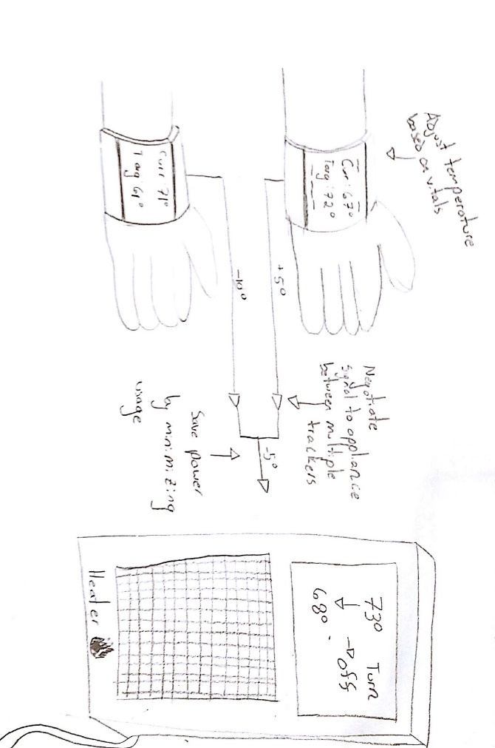

Figure 1 Maintain comfortable temperature

## New Doc 2017-01-26 - Page 2New Doc 2017-01-26 - Page 3New Doc 2017-01-26 - Page 1

Figure 4 Keep Everyone Accountable

Figure 3 Pay what you use

Figure 2 Turn lights off when room isn’t occupied

## Design 2 – On Appliance

The second design is a decentralized approach based around each individual appliance (sink, light switch, thermostat, oven, garbage cans, etc.). The appliances each have a screen to display usage information, and can be controlled via voice-activation. People can control utilities remotely through this voice activation (Figure 5), and the appliances can remind you to turn them off when leaving the room (Figure 6). Each device is surrounded by LEDs. Every person in the house is assigned a color, and the devices can light up to indicate the current person using it as well as which person uses the device the most. When prompted, graphs of usage for that specific device, also color-coded by who used it (Figure 7), will be shown allowing people to compare their usage. Additionally, the screens by the devices can show the cost and environmental impact of usage, including projected costs based on current usage.

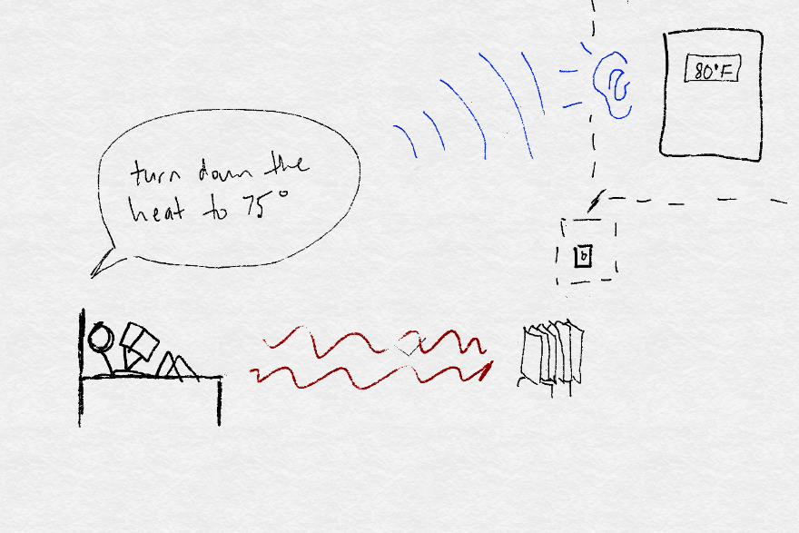

Figure 5 Maintain comfortable temperature

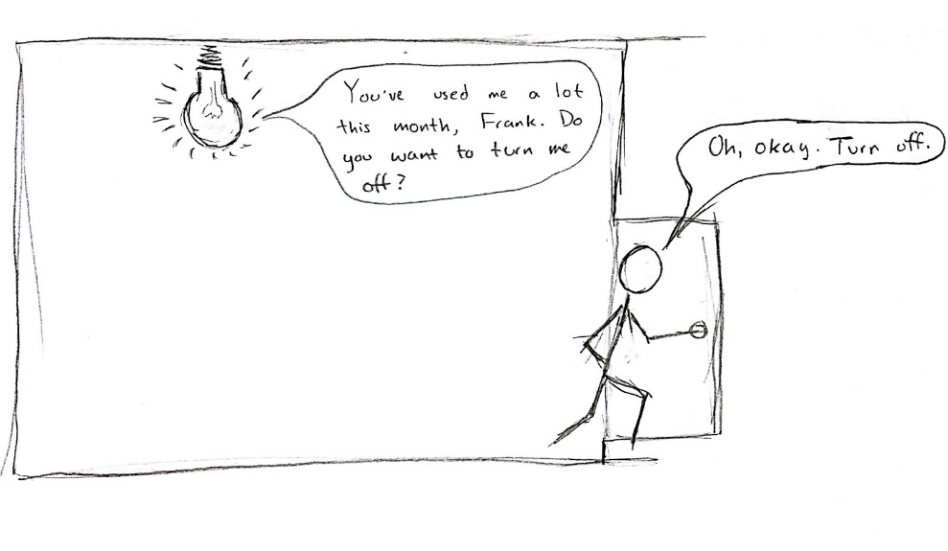

Figure 6 Turn lights off when room isn’t occupied

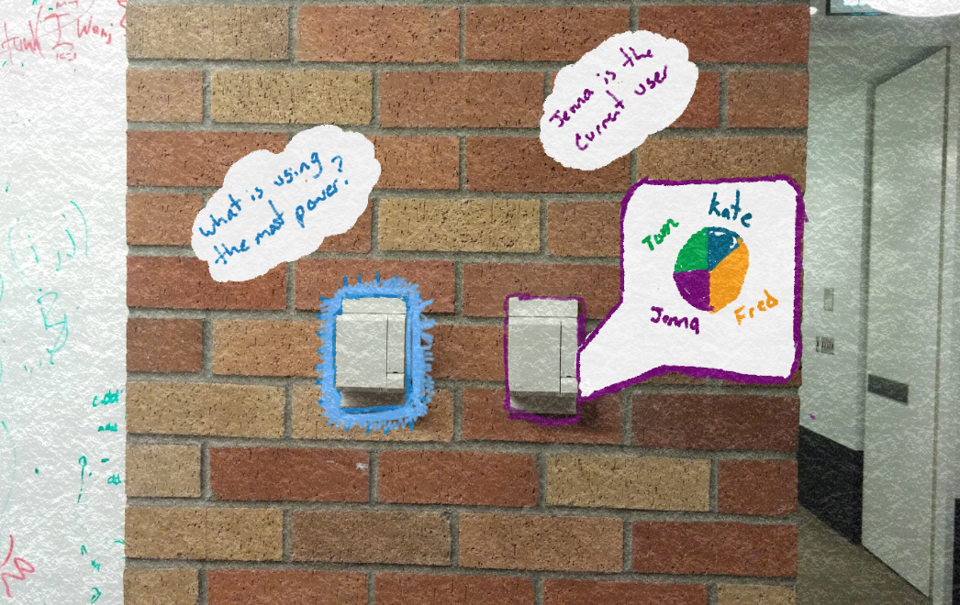

Figure 7 Compare Your Usage

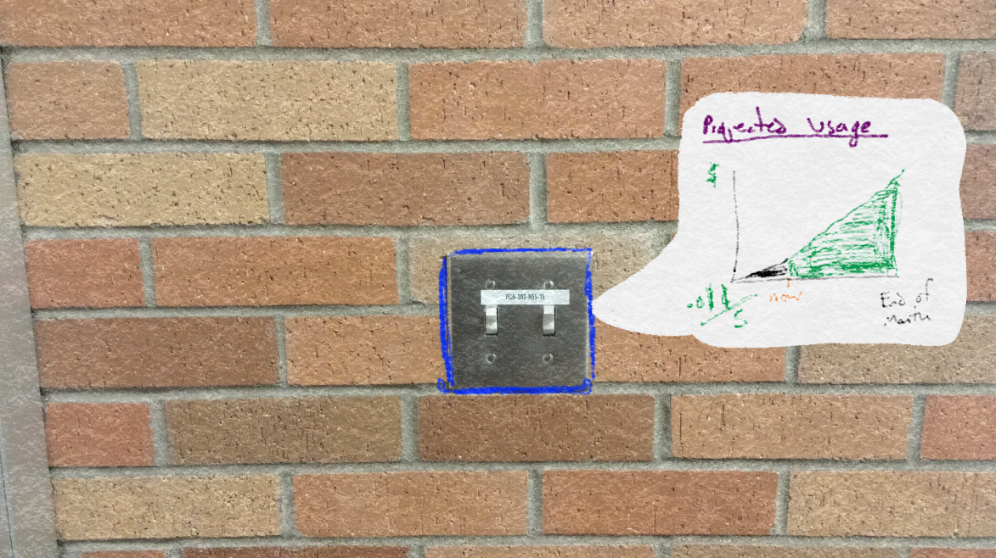

Figure 8 Understand your environment impact

## Design 3 – Hub

This design is a centralized hub that is located in a high-traffic area of the home. It keeps track of data from various appliances as well as who used them, and uses this information to charge roommates based on how much they used at the end of the bill cycle (Figure 9). The hub has various screens that can be viewed. One of these displays is a leaderboard, which compares the usage of roommates for the current bill cycle (Figure 10). The hub also has a persona that reacts to who is in the room, showing a happy and “green” environmental background when someone who is efficient is in the room, and the opposite when someone at the bottom of the leaderboard is in the room (Figure 10). Another is the 4D model of the house, which lets people see what appliances have been used over time, color-coded by roommate (Figure 11). Lastly, there is a screen which shows graphs of usage both comparatively and projected for the individual. The hub can make recommendations for how to reduce cost and environmental impact based on these usage graphs (Figure 12).

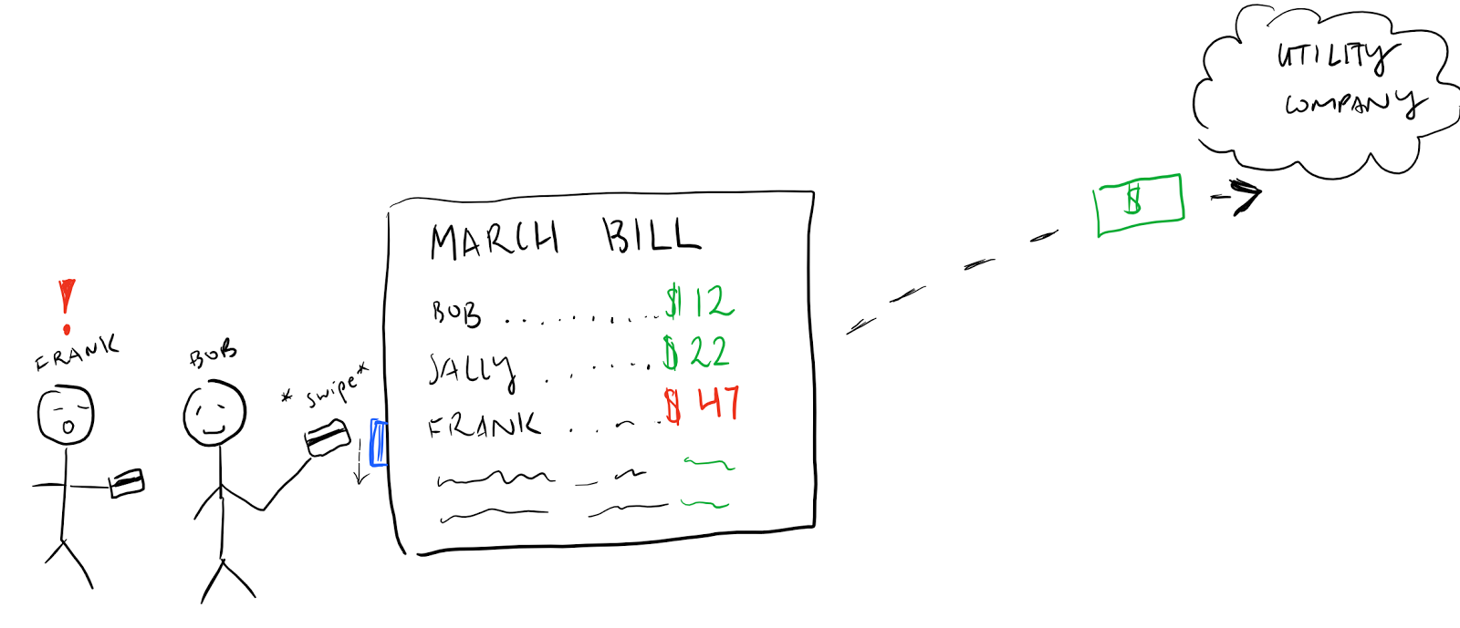

Figure 9 Pay Only What You Use

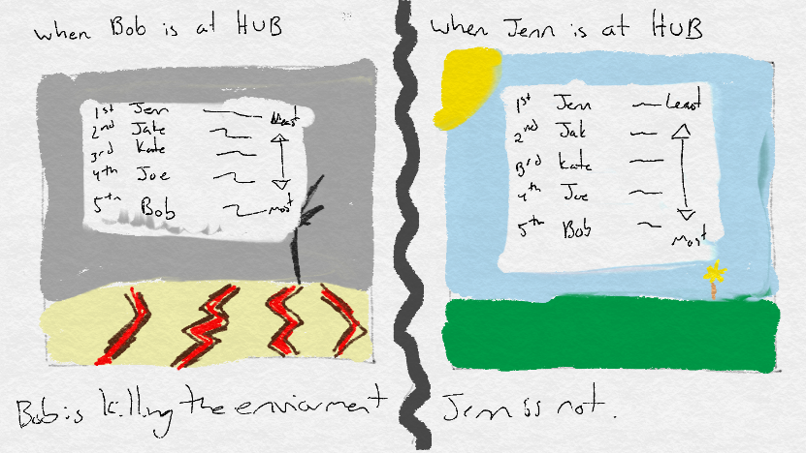

Figure 10 Compare Your Usage

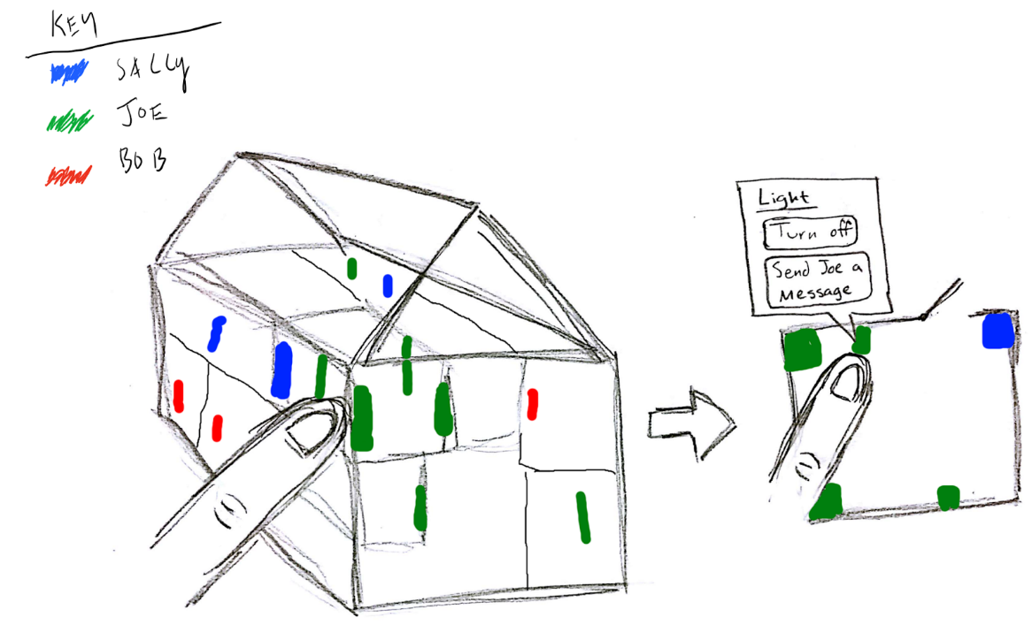

Figure 11 Keep Everyone Accountable

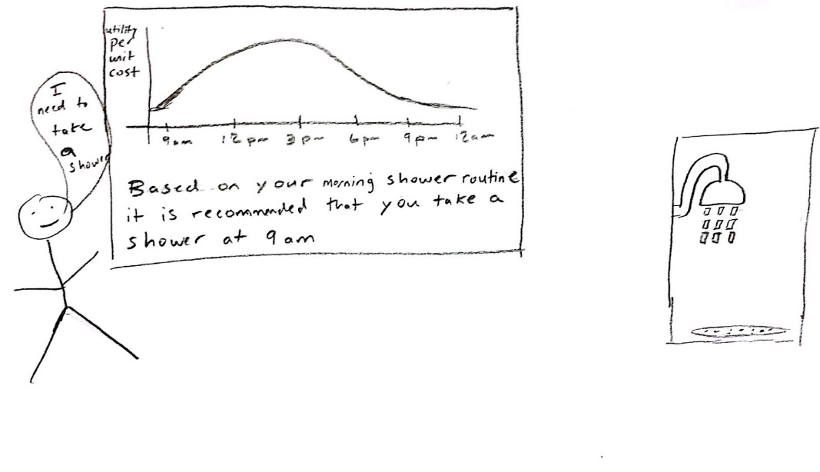

Figure 12 Understand Your Impact

## Choice of Design

We chose to pursue the hub for our design, although we also intend to include elements of the other designs, such as the color-coded LEDs from the On Appliance design. The two tasks that we chose to focus on are “control appliances remotely” and “compare your usage/keep everyone accountable”. We noticed in our design sketches that some of our tasks could (and should) be condensed, and for some tasks, a design that accomplishes one would inherently accomplish the other. For example, turning off lights and maintaining a comfortable temperature are essentially the same task, and so are compare your usage and keep everyone accountable. We chose to focus on these two condensed tasks because people interact with their utilities in a cycle of information and action. Currently, they receive feedback from their bill, but this information is delayed, so they do not know what actions to take, and it is easier to take the less efficient action. Our goal with this design and these tasks is to shorten this cycle, allowing people to receive immediate feedback and enabling people to be efficient.

# Written Scenarios - 1x2

## Task 1 - Compare Your Usage - Information

Joe is a student living in shared housing with four roommates. For the past month, he hasn’t paid attention to his utility usage, because he was busy with schoolwork and it was not a priority to him. That changes when he receives his bill for the month and it is very high. He wonders why it’s so expensive, so he heads to the hub to find out. Once he enters the room, the background of the hub changes to a sad and barren desert, indicating that Joe is extremely inefficient with his energy usage. He also notices that he is last in the house leaderboard, meaning that he uses the most utilities. Joe navigates to the 4D house model, scrolling back in time through the month. He notices, through the color-coded appliances that show up in the model of the house, that he always leaves specific lights on. Next, he checks a graph of his utility consumption in order to see his past and projected usage. Now that he has information regarding his utility usage, Joe knows what he should change in the future to be more efficient, reduce his bill, and hopefully reach the top of the house leaderboard.

## Task 2: Control Appliances Remotely (Action)

Joe is about to go to bed, and he notices that his light is still on. He looks at the light switch and sees the LEDs are lit up with his color, green. This means that if the light stays on, he will be charged for the usage; however, he doesn’t want to get out of bed. Armed with the information from checking the hub earlier, Joe knows that leaving lights on is why his bill was so high. Without needing to get out of bed, Joe uses the voice activation to turn the light off. He then goes to sleep knowing he has saved money and energy. At the end of the month, when the bill is split based on usage, Joe’s bill is less expensive than his roommates.

# Storyboards

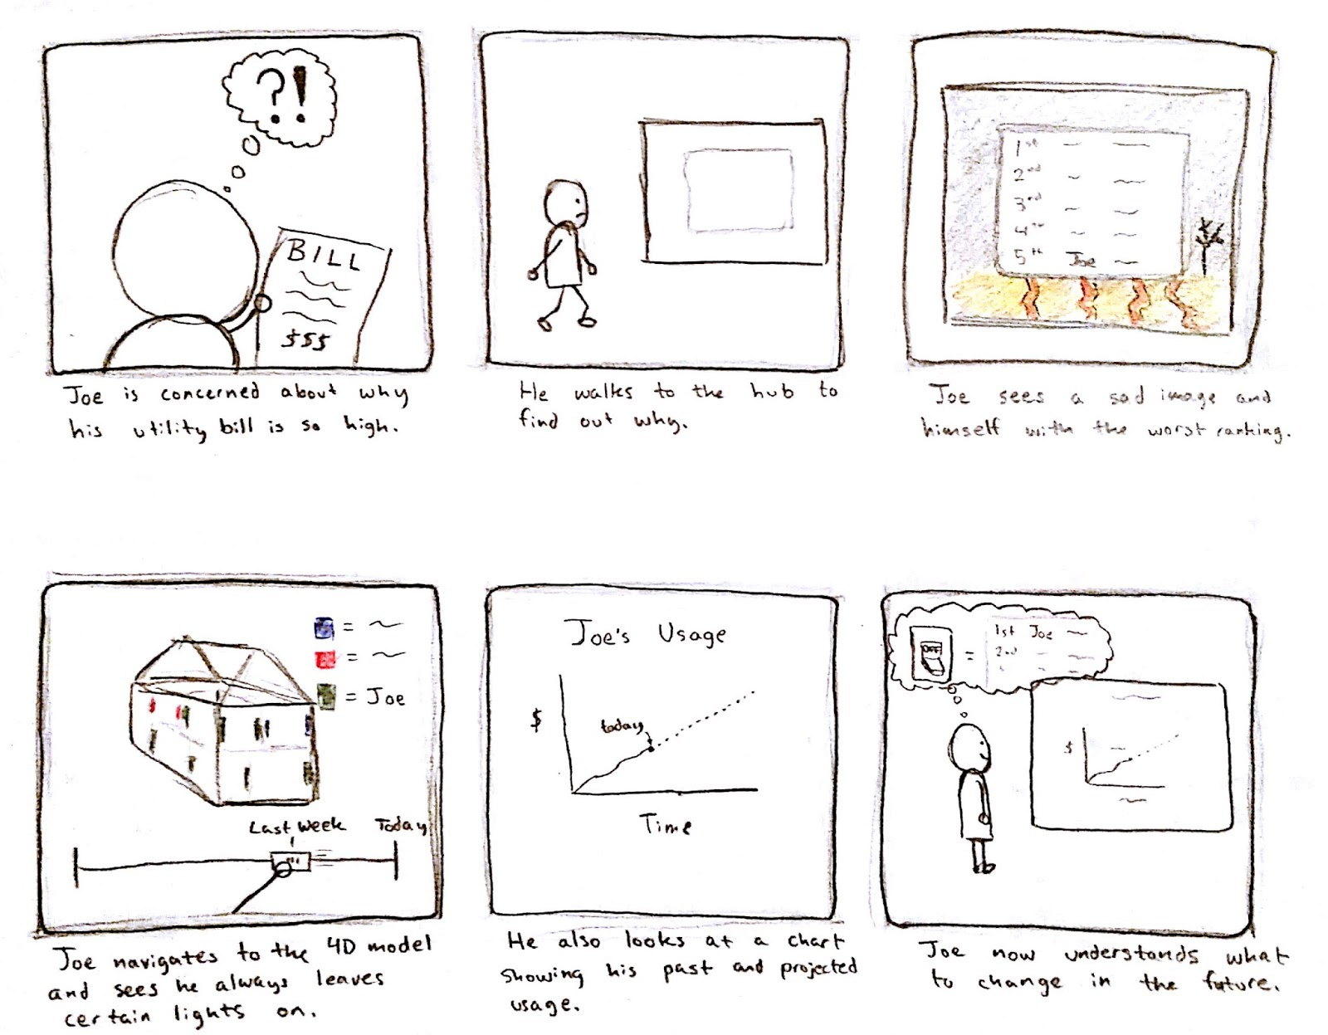

Figure 13 Storyboard 1

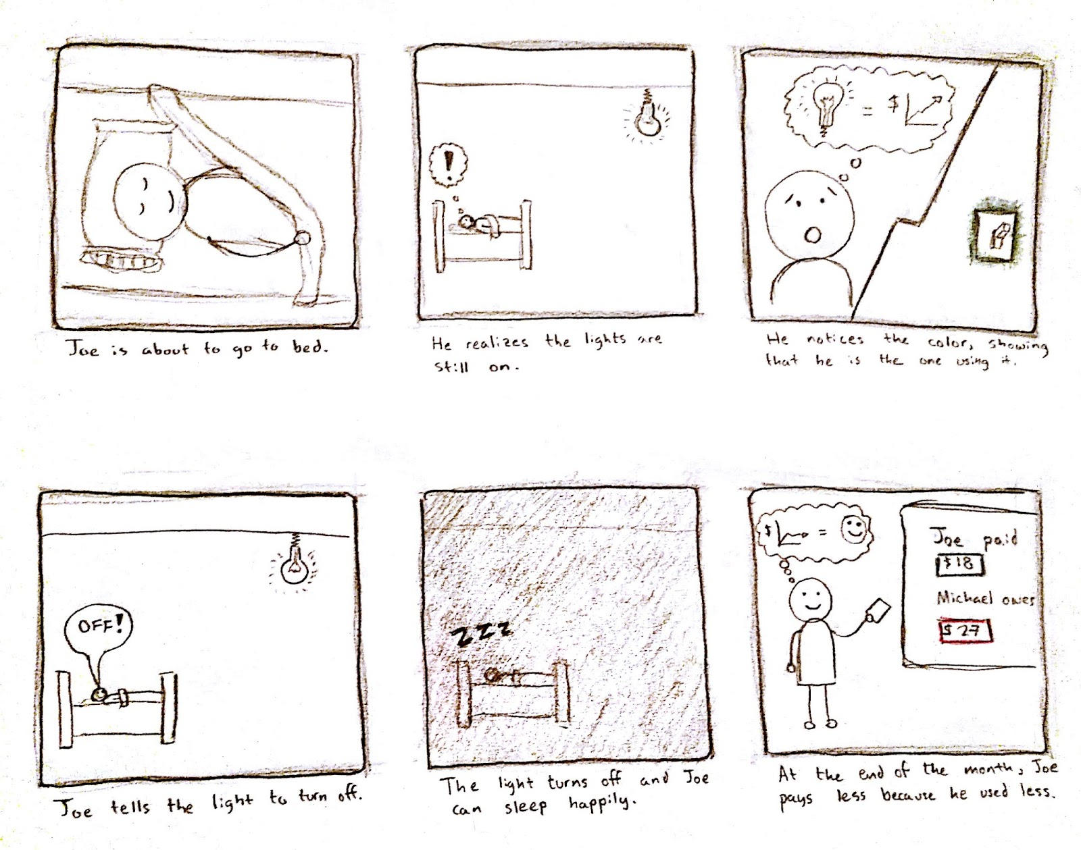

Figure 14 Storyboard 2